BDMD系列
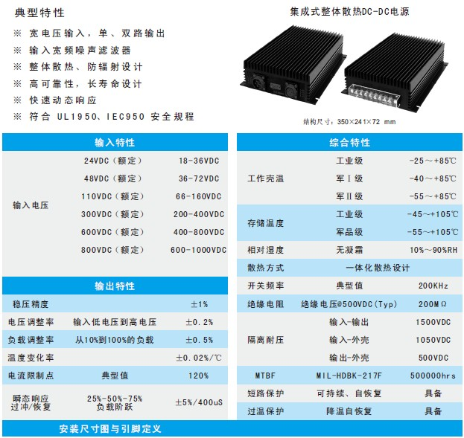
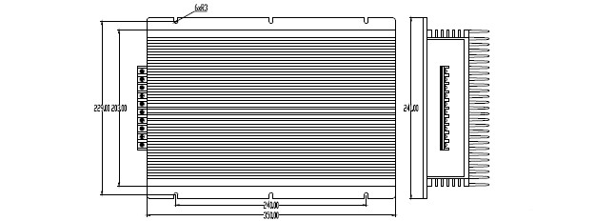
产品型号 | 标准输入 | 输入电压 | 输出电压 | 输出电流 | 纹波和噪声 | 效率
BDMD750-24S24 | 24 | 18-36 | 24 | 31.25 | 200 | 85
BDMD750-24S28 | 24 | 18-36 | 28 | 26.78 | 200 | 86
BDMD1000-24S24 | 24 | 18-36 | 24 | 41.67 | 200 | 87
BDMD1000-24S48 | 24 | 18-36 | 48 | 20.83 | 300 | 88
BDMD1500-24S24 | 24 | 18-36 | 24 | 62.5 | 200 | 87
BDMD1500-24S48 | 24 | 18-36 | 48 | 31.25 | 300 | 88
BDMD750-24D12&12 | 24 | 18-36 | 12&12 | 31.25/31.25 | 120/120 | 86
BDMD1000-24D24&24 | 24 | 18-36 | 24&24 | 20.83/20.83 | 200/200 | 87
BDMD1500-24D48&48 | 24 | 18-36 | 48&48 | 15.63/15.63 | 300/300 | 88
BDMD750-48S24 | 48 | 36-72 | 24 | 31.25 | 200 | 85
BDMD750-48S28 | 48 | 36-72 | 28 | 26.78 | 200 | 86
BDMD1000-48S24 | 48 | 36-72 | 24 | 41.67 | 200 | 87
BDMD1000-48S48 | 48 | 36-72 | 48 | 20.83 | 300 | 88
BDMD1500-48S24 | 48 | 36-72 | 24 | 62.5 | 200 | 87
BDMD1500-48S48 | 48 | 36-72 | 48 | 31.25 | 300 | 88
BDMD750-48D12&12 | 48 | 36-72 | 12&12 | 31.25/31.25 | 120/120 | 86
BDMD1000-48D24&24 | 48 | 36-72 | 24&24 | 20.83/20.83 | 200/200 | 87
BDMD1500-48D48&48 | 48 | 36-72 | 48&48 | 15.63/15.63 | 300/300 | 88
BDMD750-110S24 | 110 | 66-160 | 24 | 31.25 | 200 | 85
BDMD750-110S28 | 110 | 66-160 | 28 | 26.78 | 200 | 86
BDMD1000-110S24 | 110 | 66-160 | 24 | 41.67 | 200 | 87
BDMD1000-110S48 | 110 | 66-160 | 48 | 20.83 | 300 | 88
BDMD1500-110S24 | 110 | 66-160 | 24 | 62.5 | 200 | 87
BDMD1500-110S48 | 110 | 66-160 | 48 | 31.25 | 300 | 88
BDMD750-110D12&12 | 110 | 66-160 | 12&12 | 31.25/31.25 | 120/120 | 86
BDMD1000-110D24&24 | 110 | 66-160 | 24&24 | 20.83/20.83 | 200/200 | 87
BDMD1500-110D48&48 | 110 | 66-160 | 48&48 | 15.63/15.63 | 300/300 | 88
BDMD750-300S24 | 300 | 200-400 | 24 | 31.25 | 200 | 85
BDMD750-300S28 | 300 | 200-400 | 28 | 26.78 | 200 | 86
BDMD1000-300S24 | 300 | 200-400 | 24 | 41.67 | 200 | 87
BDMD1000-300S48 | 300 | 200-400 | 48 | 20.83 | 300 | 88
BDMD1500-300S24 | 300 | 200-400 | 24 | 62.5 | 200 | 87
BDMD1500-300S48 | 300 | 200-400 | 48 | 31.25 | 300 | 88
BDMD750-300D12&12 | 300 | 200-400 | 12&12 | 31.25/31.25 | 120/120 | 86
BDMD1000-300D24&24 | 300 | 200-400 | 24&24 | 20.83/20.83 | 200/200 | 87
BDMD1500-300D48&48 | 300 | 200-400 | 48&48 | 15.63/15.63 | 300/300 | 88
BDMD750-600S24 | 600 | 400-800 | 24 | 31.25 | 200 | 85
BDMD750-600S28 | 600 | 400-800 | 28 | 26.78 | 200 | 86
BDMD1000-600S24 | 600 | 400-800 | 24 | 41.67 | 200 | 87
BDMD1000-600S48 | 600 | 400-800 | 48 | 20.83 | 300 | 88
BDMD1500-600S24 | 600 | 400-800 | 24 | 62.5 | 200 | 87
BDMD1500-600S48 | 600 | 400-800 | 48 | 31.25 | 300 | 88
BDMD750-600D12&12 | 600 | 400-800 | 12&12 | 31.25/31.25 | 120/120 | 86
BDMD1000-600D24&24 | 600 | 400-800 | 24&24 | 20.83/20.83 | 200/200 | 87
BDMD1500-600D48&48 | 600 | 400-800 | 48&48 | 15.63/15.63 | 300/300 | 88
BDMD750-800S24 | 800 | 600-1000 | 24 | 31.25 | 200 | 84
BDMD750-800S28 | 800 | 600-1000 | 28 | 26.78 | 200 | 85
BDMD1000-800S24 | 800 | 600-1000 | 24 | 41.67 | 200 | 85
BDMD1000-800S28 | 800 | 600-1000 | 28 | 35.71 | 200 | 84
BDMD1000-800S48 | 800 | 600-1000 | 48 | 20.83 | 300 | 86

