CAEZ系列
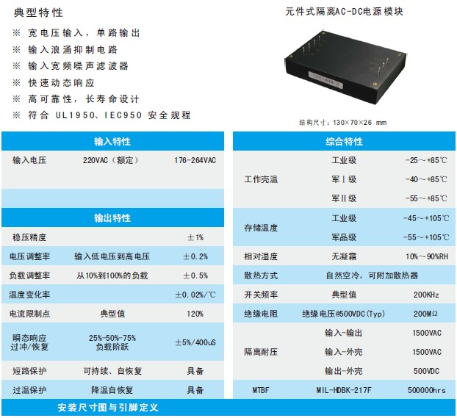
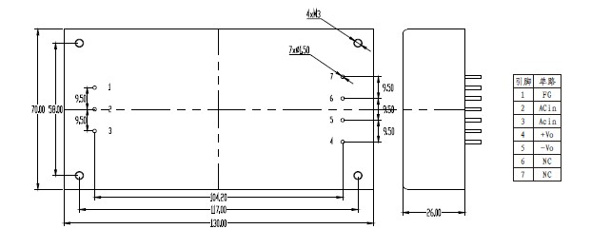
产品型号 | 标准输入 | 输入电压 | 输出电压 | 输出电流 | 纹波和噪声 | 效率
CAEZ75-220S05 | 220 | 176-264 | 5 | 15 | 50 | 83
CAEZ75-220S09 | 220 | 176-264 | 9 | 8.33 | 70 | 82
CAEZ75-220S12 | 220 | 176-264 | 12 | 6.25 | 120 | 82
CAEZ75-220S13.8 | 220 | 176-264 | 13.8 | 5.43 | 120 | 83
CAEZ75-220S15 | 220 | 176-264 | 15 | 5 | 150 | 84
CAEZ75-220S18 | 220 | 176-264 | 18 | 4.17 | 150 | 85
CAEZ75-220S24 | 220 | 176-264 | 24 | 3.13 | 200 | 85
CAEZ75-220S28 | 220 | 176-264 | 28 | 2.68 | 250 | 84
CAEZ75-220S36 | 220 | 176-264 | 36 | 2.08 | 300 | 83
CAEZ75-220S48 | 220 | 176-264 | 48 | 1.56 | 300 | 83
CAEZ75-220S68 | 220 | 176-264 | 68 | 1.1 | 300 | 84
CAEZ100-220S09 | 220 | 176-264 | 9 | 11.11 | 70 | 84
CAEZ100-220S12 | 220 | 176-264 | 12 | 8.33 | 120 | 85
CAEZ100-220S13.8 | 220 | 176-264 | 13.8 | 7.25 | 120 | 83
CAEZ100-220S15 | 220 | 176-264 | 15 | 6.67 | 150 | 82
CAEZ100-220S18 | 220 | 176-264 | 18 | 5.56 | 150 | 82
CAEZ100-220S24 | 220 | 176-264 | 24 | 4.17 | 200 | 83
CAEZ100-220S28 | 220 | 176-264 | 28 | 3.57 | 250 | 84
CAEZ100-220S36 | 220 | 176-264 | 36 | 2.78 | 300 | 85
CAEZ100-220S48 | 220 | 176-264 | 48 | 2.08 | 300 | 85
CAEZ100-220S68 | 220 | 176-264 | 68 | 1.47 | 300 | 84
CAEZ125-220S12 | 220 | 176-264 | 12 | 10.42 | 120 | 83
CAEZ125-220S13.8 | 220 | 176-264 | 13.8 | 9.06 | 120 | 83
CAEZ125-220S15 | 220 | 176-264 | 15 | 8.33 | 150 | 84
CAEZ125-220S18 | 220 | 176-264 | 18 | 6.94 | 150 | 84
CAEZ125-220S24 | 220 | 176-264 | 24 | 5.21 | 200 | 85
CAEZ125-220S28 | 220 | 176-264 | 28 | 4.46 | 250 | 82
CAEZ125-220S36 | 220 | 176-264 | 36 | 3.47 | 300 | 82
CAEZ125-220S48 | 220 | 176-264 | 48 | 2.60 | 300 | 83
CAEZ125-220S68 | 220 | 176-264 | 68 | 1.84 | 300 | 84
CAEZ125-220S110 | 220 | 176-264 | 110 | 1.14 | 300 | 85
CAEZ125-220S220 | 220 | 176-264 | 220 | 0.57 | 300 | 85
CAEZ150-220S12 | 220 | 176-264 | 12 | 12.5 | 120 | 84
CAEZ150-220S13.8 | 220 | 176-264 | 13.8 | 10.87 | 120 | 83
CAEZ150-220S15 | 220 | 176-264 | 15 | 10 | 150 | 83
CAEZ150-220S18 | 220 | 176-264 | 18 | 8.33 | 150 | 84
CAEZ150-220S24 | 220 | 176-264 | 24 | 6.25 | 200 | 84
CAEZ150-220S28 | 220 | 176-264 | 28 | 5.36 | 250 | 85
CAEZ150-220S36 | 220 | 176-264 | 36 | 4.17 | 300 | 82
CAEZ150-220S48 | 220 | 176-264 | 48 | 3.13 | 300 | 82
CAEZ150-220S68 | 220 | 176-264 | 68 | 2.21 | 300 | 83
CAEZ150-220S110 | 220 | 176-264 | 110 | 1.36 | 300 | 84
CAEZ150-220S220 | 220 | 176-264 | 220 | 0.68 | 300 | 85

