CDBZ系列
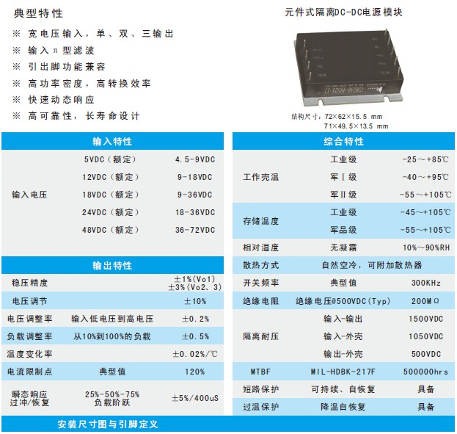
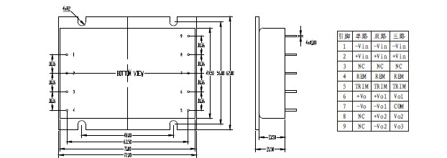
产品型号 | 标准输入 | 输入电压 | 输出电压 | 输出电流 | 纹波和噪声 | 效率
CDBZ25-05S05 | 5 | 4.5-9 | 5 | 5 | 50 | 83
CDBZ25-05S12 | 5 | 4.5-9 | 12 | 2.08 | 120 | 83
CDBZ30-05S05 | 5 | 4.5-9 | 5 | 6 | 50 | 84
CDBZ30-05S12 | 5 | 4.5-9 | 12 | 2.5 | 120 | 83
CDBZ30-05S15 | 5 | 4.5-9 | 15 | 2 | 150 | 84
CDBZ40-05S12 | 5 | 4.5-9 | 12 | 3.33 | 120 | 83
CDBZ40-05S24 | 5 | 4.5-9 | 24 | 1.67 | 000 | 84
CDBZ30-12S05 | 12 | 9-18 | 5 | 6 | 50 | 85
CDBZ30-12S12 | 12 | 9-18 | 12 | 2.5 | 120 | 83
CDBZ30-12S24 | 12 | 9-18 | 24 | 1.25 | 200 | 84
CDBZ40-12S15 | 12 | 9-18 | 15 | 2.67 | 150 | 85
CDBZ40-12S24 | 12 | 9-18 | 24 | 1.67 | 200 | 85
CDBZ25-12D05&05 | 12 | 9-18 | 05&05 | 2.5&2.5 | 50&50 | 83
CDBZ25-12D05&12 | 12 | 9-18 | 05&12 | 1&1.67 | 50&120 | 84
CDBZ30-12D05&05 | 12 | 9-18 | 05&05 | 3&3 | 50&50 | 83
CDBZ30-12D05&12 | 12 | 9-18 | 05&12 | 2&1.67 | 50&120 | 85
CDBZ30-12T05+12 | 12 | 9-18 | ±05+12 | 2/2/0.8 | 50/50/120 | 84
CDBZ25-24S05 | 24 | 18-36 | 5 | 5 | 50 | 84
CDBZ25-24S12 | 24 | 18-36 | 12 | 2.08 | 120 | 84
CDBZ25-24S24 | 24 | 18-36 | 24 | 1.04 | 200 | 85
CDBZ30-24S24 | 24 | 18-36 | 24 | 1.25 | 200 | 85
CDBZ40-24S05 | 24 | 18-36 | 5 | 8 | 50 | 84
CDBZ40-24S12 | 24 | 18-36 | 12 | 3.33 | 120 | 85
CDBZ40-24S24 | 24 | 18-36 | 24 | 1.67 | 200 | 85
CDBZ30-24D05&12 | 24 | 18-36 | 05&12 | 2&1.67 | 50&120 | 84
CDBZ30-24D05&24 | 24 | 18-36 | 05&24 | 1&1 | 50&200 | 84
CDBZ40-24D12&12 | 24 | 18-36 | 12&12 | 1.67&1.67 | 120&120 | 83
CDBZ40-24D12&24 | 24 | 18-36 | 12&24 | 1.25&1 | 120&200 | 84
CDBZ40-24T12+05 | 24 | 18-36 | ±12+05 | 0.7/0.7/5 | 120/120/50 | 84
CDBZ40-24T15+05 | 24 | 18-36 | ±15+05 | 0.67/0.67/4 | 150/150/20 | 85
CDBZ30-48S05 | 48 | 36-72 | 5 | 6 | 50 | 84
CDBZ30-48S12 | 48 | 36-72 | 12 | 2.5 | 120 | 85
CDBZ30-48S24 | 48 | 36-72 | 24 | 1.25 | 200 | 84
CDBZ40-48S05 | 48 | 36-72 | 5 | 8 | 50 | 83
CDBZ40-48S12 | 48 | 36-72 | 12 | 3.33 | 120 | 84
CDBZ40-48S24 | 48 | 36-72 | 24 | 1.67 | 200 | 84
CDBZ30-48D05&12 | 48 | 36-72 | 05&12 | 2&1.67 | 50&120 | 83
CDBZ30-48D05&24 | 48 | 36-72 | 05&24 | 1&1 | 50&200 | 84
CDBZ40-48D12&12 | 48 | 36-72 | 12&12 | 1.67&1.67 | 120&120 | 84
CDBZ40-48D12&24 | 48 | 36-72 | 12&24 | 1.25&1 | 120&200 | 85
CDBZ30-48T05+15 | 48 | 36-72 | ±05+15 | 2/2/0.7 | 50/50/150 | 83
CDBZ40-48T15+05 | 48 | 36-72 | ±15+05 | 0.67/0.67/4 | 150/150/50 | 84
CDBZ25-18S05 | 18 | 9-36 | 5 | 5 | 50 | 83
CDBZ25-18S12 | 18 | 9-36 | 12 | 2.08 | 120 | 83
CDBZ25-18S24 | 18 | 9-36 | 24 | 1.04 | 200 | 84
CDBZ30-18S05 | 18 | 9-36 | 5 | 6 | 50 | 85
CDBZ30-18S12 | 18 | 9-36 | 12 | 2.5 | 120 | 83
CDBZ30-18S24 | 18 | 9-36 | 24 | 1.25 | 200 | 84
CDBZ40-18S15 | 18 | 9-36 | 15 | 2.67 | 150 | 84
CDBZ40-18S24 | 18 | 9-36 | 24 | 1.67 | 200 | 85

