CDCZ系列
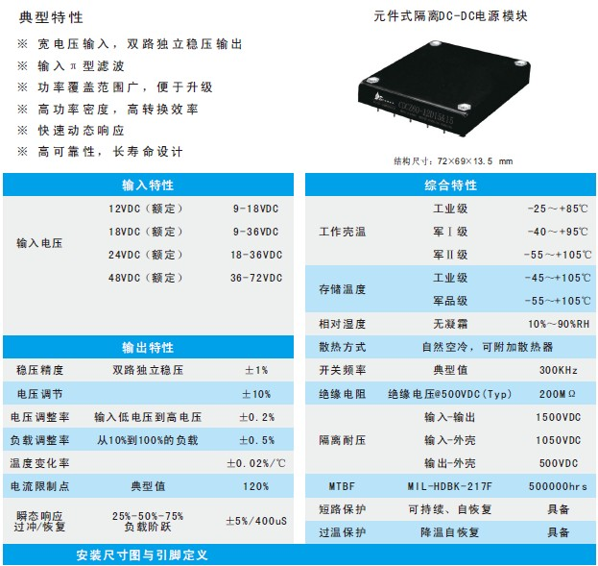
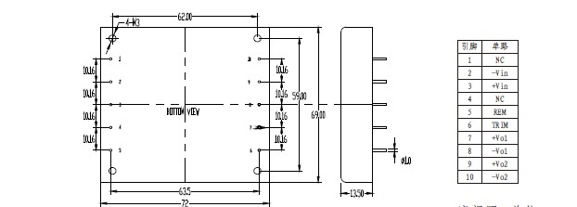
产品型号 | 标准输入 | 输入电压 | 输出电压 | 输出电流 | 纹波和噪声 | 效率
CDCZ60-12D05&05 | 12 | 9-18 | 05&05 | 8&4 | 50&50 | 82
CDCZ60-12D05&05 | 12 | 9-18 | 05&05 | 6&6 | 50&50 | 82
CDCZ60-12D05&12 | 12 | 9-18 | 05&12 | 4&3.33 | 50&120 | 83
CDCZ60-12D05&24 | 12 | 9-18 | 05&24 | 2&2.08 | 50&200 | 83
CDCZ60-12D09&09 | 12 | 9-18 | 09&09 | 3.33&3.33 | 70&70 | 83
CDCZ60-12D12&12 | 12 | 9-18 | 12&12 | 2.5&2.5 | 120&120 | 83
CDCZ60-12D12&15 | 12 | 9-18 | 12&15 | 3&1.6 | 120&150 | 83
CDCZ60-12D12&24 | 12 | 9-18 | 12&24 | 1.67&1.67 | 120&200 | 84
CDCZ60-12D15&15 | 12 | 9-18 | 15&15 | 2&2 | 150&150 | 83
CDCZ60-12D24&24 | 12 | 9-18 | 24&24 | 1.25&1.25 | 200&200 | 85
CDCZ60-12D28&28 | 12 | 9-18 | 28&28 | 1.07&1.07 | 200&200 | 85
CDCZ60-12D48&48 | 12 | 9-18 | 48&48 | 0.63&0.63 | 300&300 | 85
CDCZ60-24D05&05 | 24 | 18-36 | 05&05 | 8&4 | 50&50 | 82
CDCZ60-24D05&05 | 24 | 18-36 | 05&05 | 6&6 | 50&50 | 82
CDCZ60-24D05&12 | 24 | 18-36 | 05&12 | 4&3.33 | 50&120 | 83
CDCZ60-24D05&24 | 24 | 18-36 | 05&24 | 2&2.08 | 50&200 | 83
CDCZ60-24D09&09 | 24 | 18-36 | 09&09 | 3.33&3.33 | 70&70 | 83
CDCZ60-24D12&12 | 24 | 18-36 | 12&12 | 2.5&2.5 | 120&120 | 83
CDCZ60-24D12&15 | 24 | 18-36 | 12&15 | 3&1.6 | 120&150 | 83
CDCZ60-24D12&24 | 24 | 18-36 | 12&24 | 1.67&1.67 | 120&200 | 84
CDCZ60-24D15&15 | 24 | 18-36 | 15&15 | 2&2 | 150&150 | 83
CDCZ60-24D24&24 | 24 | 18-36 | 24&24 | 1.25&1.25 | 200&200 | 85
CDCZ60-24D28&28 | 24 | 18-36 | 28&28 | 1.07&1.07 | 200&200 | 85
CDCZ60-24D48&48 | 24 | 18-36 | 48&48 | 0.63&0.63 | 300&300 | 85
CDCZ60-48D05&05 | 48 | 36-72 | 05&05 | 8&4 | 50&50 | 82
CDCZ60-48D05&05 | 48 | 36-72 | 05&05 | 6&6 | 50&50 | 82
CDCZ60-48D05&12 | 48 | 36-72 | 05&12 | 4&3.33 | 50&120 | 83
CDCZ60-48D05&24 | 48 | 36-72 | 05&24 | 2&2.08 | 50&200 | 83
CDCZ60-48D09&09 | 48 | 36-72 | 09&09 | 3.33&3.33 | 70&70 | 83
CDCZ60-48D12&12 | 48 | 36-72 | 12&12 | 2.5&2.5 | 120&120 | 83
CDCZ60-48D12&15 | 48 | 36-72 | 12&15 | 3&1.6 | 120&150 | 83
CDCZ60-48D12&24 | 48 | 36-72 | 12&24 | 1.67&1.67 | 120&200 | 84
CDCZ60-48D15&15 | 48 | 36-72 | 15&15 | 2&2 | 150&150 | 83
CDCZ60-48D24&24 | 48 | 36-72 | 24&24 | 1.25&1.25 | 200&200 | 85
CDCZ60-48D28&28 | 48 | 36-72 | 28&28 | 1.07&1.07 | 200&200 | 85
CDCZ60-48D48&48 | 48 | 36-72 | 48&48 | 0.63&0.63 | 300&300 | 85
CDCZ60-18D05&05 | 18 | 9-36 | 05&05 | 8&4 | 50&50 | 82
CDCZ60-18D05&05 | 18 | 9-36 | 05&05 | 6&6 | 50&50 | 82
CDCZ60-18D05&12 | 18 | 9-36 | 05&12 | 4&3.33 | 50&120 | 83
CDCZ60-18D05&24 | 18 | 9-36 | 05&24 | 2&2.08 | 50&200 | 83
CDCZ60-18D09&09 | 18 | 9-36 | 09&09 | 3.33&3.33 | 70&70 | 83
CDCZ60-18D12&12 | 18 | 9-36 | 12&12 | 2.5&2.5 | 120&120 | 83
CDCZ60-18D12&15 | 18 | 9-36 | 12&15 | 3&1.6 | 120&150 | 83
CDCZ60-18D12&24 | 18 | 9-36 | 12&24 | 1.67&1.67 | 120&200 | 84
CDCZ60-18D15&15 | 18 | 9-36 | 15&15 | 2&2 | 150&150 | 83
CDCZ60-18D24&24 | 18 | 9-36 | 24&24 | 1.25&1.25 | 200&200 | 85
CDCZ60-18D28&28 | 18 | 9-36 | 28&28 | 1.07&1.07 | 200&200 | 85
CDCZ60-18D48&48 | 18 | 9-36 | 48&48 | 0.63&0.63 | 300&300 | 85

