CDEZ系列
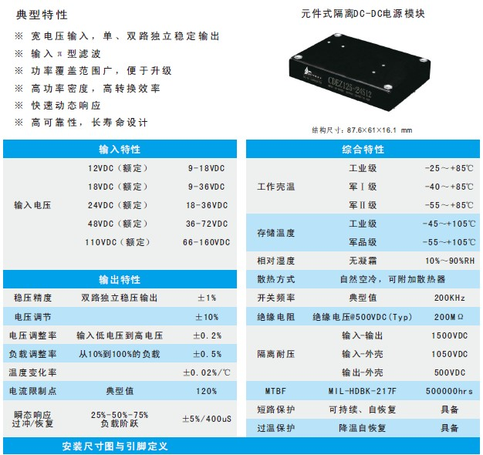
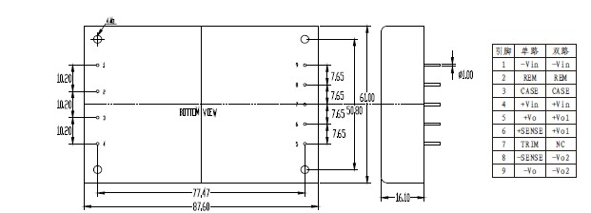
产品型号 | 标准输入 | 输入电压 | 输出电压 | 输出电流 | 纹波和噪声 | 效率
CDEZ50-12S05 | 12 | 9-18 | 5 | 10 | 50 | 82
CDEZ75-12S12 | 12 | 9-18 | 12 | 6.25 | 120 | 83
CDEZ100-12S15 | 12 | 9-18 | 15 | 6.67 | 150 | 84
CDEZ100-12S24 | 12 | 9-18 | 24 | 4.17 | 200 | 84
CDEZ100-12S48 | 12 | 9-18 | 48 | 2.08 | 300 | 85
CDEZ60-12S05 | 12 | 9-18 | 5 | 12 | 50 | 83
CDEZ100-12S12 | 12 | 9-18 | 12 | 8.33 | 120 | 84
CDEZ125-12S15 | 12 | 9-18 | 15 | 8.33 | 150 | 85
CDEZ125-12S24 | 12 | 9-18 | 24 | 5.21 | 200 | 85
CDEZ125-12S48 | 12 | 9-18 | 48 | 2.6 | 300 | 86
CDEZ50-24S05 | 24 | 18-36 | 5 | 10 | 50 | 83
CDEZ75-24S12 | 24 | 18-36 | 12 | 6.25 | 120 | 84
CDEZ100-24S15 | 24 | 18-36 | 15 | 6.67 | 150 | 85
CDEZ100-24S24 | 24 | 18-36 | 24 | 4.17 | 200 | 85
CDEZ100-24S48 | 24 | 18-36 | 48 | 2.08 | 300 | 86
CDEZ60-24S05 | 24 | 18-36 | 5 | 12 | 50 | 84
CDEZ100-24S12 | 24 | 18-36 | 12 | 8.33 | 120 | 85
CDEZ125-24S15 | 24 | 18-36 | 15 | 8.33 | 150 | 86
CDEZ125-24S24 | 24 | 18-36 | 24 | 5.21 | 200 | 86
CDEZ125-24S48 | 24 | 18-36 | 48 | 2.6 | 300 | 87
CDEZ50-48S05 | 48 | 36-72 | 5 | 10 | 50 | 83
CDEZ75-48S12 | 48 | 36-72 | 12 | 6.25 | 120 | 84
CDEZ100-48S15 | 48 | 36-72 | 15 | 6.67 | 150 | 85
CDEZ100-48S24 | 48 | 36-72 | 24 | 4.17 | 200 | 85
CDEZ100-48S48 | 48 | 36-72 | 48 | 2.08 | 300 | 86
CDEZ60-48S05 | 48 | 36-72 | 5 | 12 | 50 | 84
CDEZ100-48S12 | 48 | 36-72 | 12 | 8.33 | 120 | 85
CDEZ125-48S15 | 48 | 36-72 | 15 | 8.33 | 150 | 86
CDEZ125-48S24 | 48 | 36-72 | 24 | 5.21 | 200 | 86
CDEZ125-48S48 | 48 | 36-72 | 48 | 2.6 | 300 | 87
CDEZ50-110S05 | 110 | 66-160 | 5 | 10 | 50 | 83
CDEZ75-110S12 | 110 | 66-160 | 12 | 6.25 | 120 | 84
CDEZ100-110S15 | 110 | 66-160 | 15 | 6.67 | 150 | 85
CDEZ100-110S24 | 110 | 66-160 | 24 | 4.17 | 200 | 85
CDEZ100-110S48 | 110 | 66-160 | 48 | 2.08 | 300 | 86
CDEZ60-110S05 | 110 | 66-160 | 5 | 12 | 50 | 84
CDEZ100-110S12 | 110 | 66-160 | 12 | 8.33 | 120 | 85
CDEZ125-110S15 | 110 | 66-160 | 15 | 8.33 | 150 | 86
CDEZ125-110S24 | 110 | 66-160 | 24 | 5.21 | 200 | 86
CDEZ125-110S48 | 110 | 66-160 | 48 | 2.6 | 300 | 87
CDEZ50-18S05 | 18 | 9-36 | 5 | 10 | 50 | 82
CDEZ75-18S12 | 18 | 9-36 | 12 | 6.25 | 120 | 83
CDEZ75-18S15 | 18 | 9-36 | 15 | 5 | 150 | 84
CDEZ75-18S24 | 18 | 9-36 | 24 | 3.13 | 200 | 84
CDEZ75-18S48 | 18 | 9-36 | 48 | 1.56 | 300 | 85
CDEZ60-18S05 | 18 | 9-36 | 5 | 12 | 50 | 83
CDEZ100-18S12 | 18 | 9-36 | 12 | 8.33 | 120 | 84
CDEZ100-18S15 | 18 | 9-36 | 15 | 6.67 | 150 | 85
CDEZ100-18S24 | 18 | 9-36 | 24 | 4.17 | 200 | 85
CDEZ100-18S48 | 18 | 9-36 | 48 | 2.08 | 300 | 86

