CDKZ系列
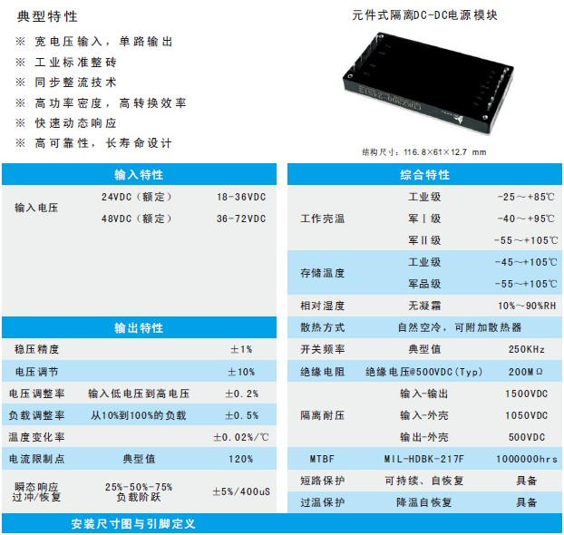
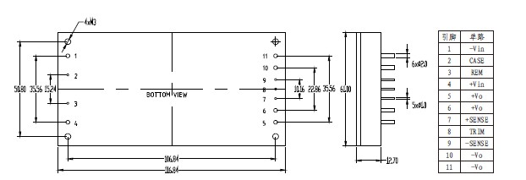
产品型号 | 标准输入 | 输入电压 | 输出电压 | 输出电流 | 纹波和噪声 | 效率
CDKZ150-24S3.3 | 24 | 18-36 | 3.3 | 45.45 | 50 | 84
CDKZ150-24S05 | 24 | 18-36 | 5 | 50 | 50 | 86
CDKZ150-24S12 | 24 | 18-36 | 12 | 12.5 | 120 | 87
CDKZ200-24S3.3 | 24 | 18-36 | 3.3 | 60 | 50 | 84
CDKZ200-24S05 | 24 | 18-36 | 5 | 40 | 50 | 85
CDKZ200-24S12 | 24 | 18-36 | 12 | 16.67 | 120 | 86
CDKZ200-24S15 | 24 | 18-36 | 15 | 13.33 | 150 | 87
CDKZ200-24S24 | 24 | 18-36 | 24 | 8.33 | 200 | 88
CDKZ200-24S28 | 24 | 18-36 | 28 | 7.14 | 250 | 88
CDKZ200-24S48 | 24 | 18-36 | 48 | 4.17 | 300 | 86
CDKZ250-24S05 | 24 | 18-36 | 5 | 50 | 50 | 85
CDKZ250-24S12 | 24 | 18-36 | 12 | 20.83 | 120 | 86
CDKZ250-24S15 | 24 | 18-36 | 15 | 16.67 | 150 | 87
CDKZ250-24S24 | 24 | 18-36 | 24 | 10.42 | 200 | 88
CDKZ250-24S28 | 24 | 18-36 | 28 | 8.93 | 250 | 88
CDKZ250-24S48 | 24 | 18-36 | 48 | 5.21 | 300 | 87
CDKZ300-24S12 | 24 | 18-36 | 12 | 25 | 120 | 88
CDKZ300-24S15 | 24 | 18-36 | 15 | 20 | 150 | 88
CDKZ300-24S24 | 24 | 18-36 | 24 | 12.5 | 200 | 88
CDKZ300-24S28 | 24 | 18-36 | 28 | 10.71 | 250 | 88
CDKZ300-24S48 | 24 | 18-36 | 48 | 6.25 | 300 | 87
CDKZ400-24S12 | 24 | 18-36 | 12 | 33.33 | 120 | 87
CDKZ400-24S24 | 24 | 18-36 | 24 | 16.67 | 200 | 88
CDKZ400-24S28 | 24 | 18-36 | 28 | 14.28 | 250 | 88
CDKZ400-24S48 | 24 | 18-36 | 48 | 8.33 | 300 | 87
CDKZ150-48S3.3 | 48 | 36-72 | 3.3 | 45.45 | 50 | 85
CDKZ150-48S05 | 48 | 36-72 | 5 | 50 | 50 | 87
CDKZ150-48S12 | 48 | 36-72 | 12 | 12.5 | 120 | 88
CDKZ200-48S3.3 | 48 | 36-72 | 3.3 | 60 | 50 | 85
CDKZ200-48S05 | 48 | 36-72 | 5 | 40 | 50 | 86
CDKZ200-48S12 | 48 | 36-72 | 12 | 16.67 | 120 | 87
CDKZ200-48S15 | 48 | 36-72 | 15 | 13.33 | 150 | 87
CDKZ200-48S24 | 48 | 36-72 | 24 | 8.33 | 200 | 88
CDKZ200-48S28 | 48 | 36-72 | 28 | 7.14 | 250 | 89
CDKZ200-48S48 | 48 | 36-72 | 48 | 4.17 | 300 | 88
CDKZ250-48S05 | 48 | 36-72 | 5 | 50 | 50 | 87
CDKZ250-48S12 | 48 | 36-72 | 12 | 20.83 | 120 | 87
CDKZ250-48S15 | 48 | 36-72 | 15 | 16.67 | 150 | 88
CDKZ250-48S24 | 48 | 36-72 | 24 | 10.42 | 200 | 88
CDKZ250-48S28 | 48 | 36-72 | 28 | 8.93 | 250 | 88
CDKZ250-48S48 | 48 | 36-72 | 48 | 5.21 | 300 | 87
CDKZ300-48S12 | 48 | 36-72 | 12 | 25 | 120 | 88
CDKZ300-48S15 | 48 | 36-72 | 15 | 20 | 150 | 88
CDKZ300-48S24 | 48 | 36-72 | 24 | 12.5 | 200 | 89
CDKZ300-48S28 | 48 | 36-72 | 28 | 10.71 | 250 | 89
CDKZ300-48S48 | 48 | 36-72 | 48 | 6.25 | 300 | 88
CDKZ400-48S12 | 48 | 36-72 | 12 | 33.33 | 120 | 89
CDKZ400-48S24 | 48 | 36-72 | 24 | 16.67 | 200 | 90
CDKZ400-48S28 | 48 | 36-72 | 28 | 14.28 | 250 | 90
CDKZ400-48S48 | 48 | 36-72 | 48 | 8.33 | 300 | 88

