RAAZ系列
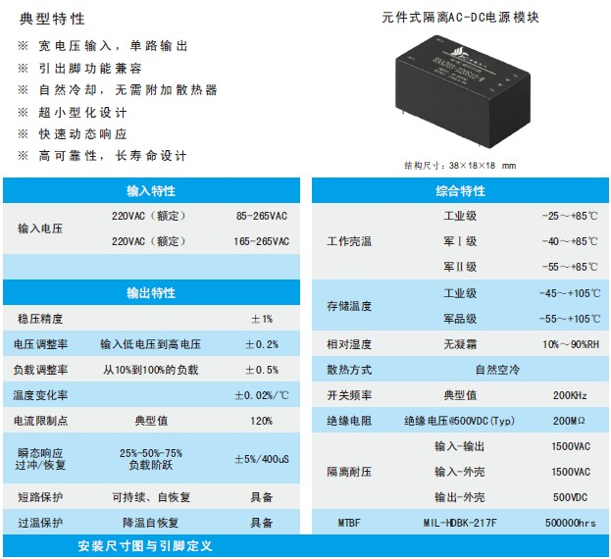
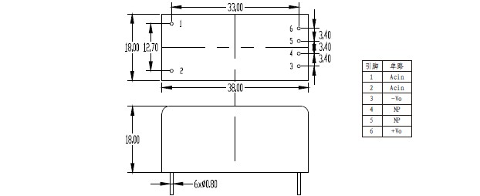
产品型号 | 标准输入 | 输入电压 | 输出电压 | 输出电流 | 纹波和噪声 | 效率
RAAZ02-220S3.3 | 220 | 165-265 | 3.3 | 0.61 | 50 | 73
RAAZ02-220S05 | 220 | 165-265 | 5 | 0.4 | 50 | 73
RAAZ02-220S09 | 220 | 165-265 | 9 | 0.22 | 70 | 74
RAAZ02-220S12 | 220 | 165-265 | 12 | 0.17 | 120 | 75
RAAZ02-220S15 | 220 | 165-265 | 15 | 0.13 | 150 | 75
RAAZ02-220S24 | 220 | 165-265 | 24 | 0.08 | 200 | 75
RAAZ02-220S28 | 220 | 165-265 | 28 | 0.07 | 250 | 75
RAAZ02-220S36 | 220 | 165-265 | 36 | 0.05 | 300 | 75
RAAZ02-220S48 | 220 | 165-265 | 48 | 0.04 | 300 | 74
RAAZ03-220S3.3 | 220 | 165-265 | 3.3 | 0.91 | 50 | 73
RAAZ03-220S05 | 220 | 165-265 | 5 | 0.6 | 50 | 73
RAAZ03-220S09 | 220 | 165-265 | 9 | 0.33 | 70 | 74
RAAZ03-220S12 | 220 | 165-265 | 12 | 0.25 | 120 | 75
RAAZ03-220S15 | 220 | 165-265 | 15 | 0.2 | 150 | 75
RAAZ03-220S24 | 220 | 165-265 | 24 | 0.13 | 200 | 75
RAAZ03-220S28 | 220 | 165-265 | 28 | 0.11 | 250 | 75
RAAZ03-220S36 | 220 | 165-265 | 36 | 0.08 | 300 | 75
RAAZ03-220S48 | 220 | 165-265 | 48 | 0.06 | 300 | 74
RAAZ02-220S3.3-W | 220 | 85-265 | 3.3 | 0.61 | 50 | 73
RAAZ02-220S05-W | 220 | 85-265 | 5 | 0.4 | 50 | 73
RAAZ02-220S09-W | 220 | 85-265 | 9 | 0.22 | 70 | 74
RAAZ02-220S12-W | 220 | 85-265 | 12 | 0.17 | 120 | 75
RAAZ02-220S15-W | 220 | 85-265 | 15 | 0.13 | 150 | 75
RAAZ02-220S24-W | 220 | 85-265 | 24 | 0.08 | 200 | 75
RAAZ02-220S28-W | 220 | 85-265 | 28 | 0.07 | 250 | 75
RAAZ02-220S36-W | 220 | 85-265 | 36 | 0.05 | 300 | 75
RAAZ02-220S48-W | 220 | 85-265 | 48 | 0.04 | 300 | 74
RAAZ03-220S3.3-W | 220 | 85-265 | 3.3 | 0.91 | 50 | 73
RAAZ03-220S05-W | 220 | 85-265 | 5 | 0.6 | 50 | 73
RAAZ03-220S09-W | 220 | 85-265 | 9 | 0.33 | 70 | 74
RAAZ03-220S12-W | 220 | 85-265 | 12 | 0.25 | 120 | 75
RAAZ03-220S15-W | 220 | 85-265 | 15 | 0.2 | 150 | 75
RAAZ03-220S24-W | 220 | 85-265 | 24 | 0.13 | 200 | 75
RAAZ03-220S28-W | 220 | 85-265 | 28 | 0.11 | 250 | 75
RAAZ03-220S36-W | 220 | 85-265 | 36 | 0.08 | 300 | 75
RAAZ03-220S48-W | 220 | 85-265 | 48 | 0.06 | 300 | 74

