RABZ系列
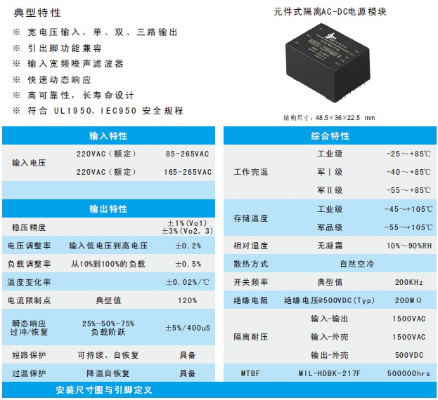
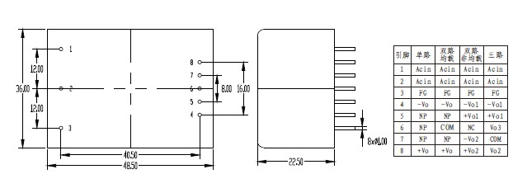
产品型号 | 标准输入 | 输入电压 | 输出电压 | 输出电流 | 纹波和噪声 | 效率
RABZ03-220S3.3 | 220 | 165-265 | 3.3 | 0.9 | 50 | 72
RABZ03-220S05 | 220 | 165-265 | 5 | 0.6 | 50 | 73
RABZ03-220S09 | 220 | 165-265 | 9 | 0.33 | 70 | 73
RABZ03-220S12 | 220 | 165-265 | 12 | 0.25 | 120 | 73
RABZ03-220S13.8 | 220 | 165-265 | 13.8 | 0.22 | 120 | 73
RABZ03-220S15 | 220 | 165-265 | 15 | 0.2 | 150 | 74
RABZ03-220S24 | 220 | 165-265 | 24 | 0.13 | 200 | 75
RABZ03-220S48 | 220 | 165-265 | 48 | 0.06 | 300 | 74
RABZ03-220D05 | 220 | 165-265 | ±05 | 0.3/0.3 | 50/50 | 72
RABZ03-220D12 | 220 | 165-265 | ±12 | 0.13/0.13 | 120/120 | 72
RABZ03-220D15 | 220 | 165-265 | ±15 | 0.1/0.1 | 150/150 | 73
RABZ03-220D24 | 220 | 165-265 | ±24 | 0.06/0.06 | 200/200 | 73
RABZ03-220D05&05 | 220 | 165-265 | 05&05 | 0.5/0.1 | 50/50 | 74
RABZ03-220D05&12 | 220 | 165-265 | 05&12 | 0.36/0.1 | 50/120 | 74
RABZ03-220D05&15 | 220 | 165-265 | 05&15 | 0.3/0.1 | 50/150 | 72
RABZ03-220D05&24 | 220 | 165-265 | 05&24 | 0.25/0.06 | 50/200 | 72
RABZ03-220D05&05 | 220 | 165-265 | 05&05 | 0.4/0.2 | 50/50 | 73
RABZ03-220D05&12 | 220 | 165-265 | 05&12 | 0.12/0.2 | 50/120 | 73
RABZ03-220D05&15 | 220 | 165-265 | 05&15 | 0.15/0.15 | 50/150 | 74
RABZ03-220D05&24 | 220 | 165-265 | 05&24 | 0.12/0.1 | 50/200 | 74
RABZ03-220T05&05 | 220 | 165-265 | ±05&05 | 0.1/0.1/0.4 | 50/50/50 | 71
RABZ03-220T05&12 | 220 | 165-265 | ±05&12 | 0.15/0.15/0.13 | 50/50/120 | 71
RABZ03-220T05&15 | 220 | 165-265 | ±05&15 | 0.15/0.15/0.1 | 50/50/150 | 71
RABZ03-220T12&5 | 220 | 165-265 | ±12&5 | 0.5/0.5/0.36 | 120/120/50 | 72
RABZ03-220T15&5 | 220 | 165-265 | ±15&5 | 0.06/0.06/0.24 | 150/150/50 | 72
RABZ03-220S3.3-W | 220 | 85-265 | 3.3 | 0.9 | 50 | 72
RABZ03-220S05-W | 220 | 85-265 | 5 | 0.6 | 50 | 73
RABZ03-220S09-W | 220 | 85-265 | 9 | 0.33 | 70 | 73
RABZ03-220S12-W | 220 | 85-265 | 12 | 0.25 | 120 | 73
RABZ03-220S13.8-W | 220 | 85-265 | 13.8 | 0.22 | 120 | 73
RABZ03-220S15-W | 220 | 85-265 | 15 | 0.2 | 150 | 74
RABZ03-220S24-W | 220 | 85-265 | 24 | 0.13 | 200 | 75
RABZ03-220S48-W | 220 | 85-265 | 48 | 0.06 | 300 | 74
RABZ03-220D05-W | 220 | 85-265 | ±05 | 0.3/0.3 | 50/50 | 72
RABZ03-220D12-W | 220 | 85-265 | ±12 | 0.13/0.13 | 120/120 | 72
RABZ03-220D15-W | 220 | 85-265 | ±15 | 0.1/0.1 | 150/150 | 73
RABZ03-220D24-W | 220 | 85-265 | ±24 | 0.06/0.06 | 200/200 | 73
RABZ03-220D05&05-W | 220 | 85-265 | 05&05 | 0.5/0.1 | 50/50 | 74
RABZ03-220D05&12-W | 220 | 85-265 | 05&12 | 0.36/0.1 | 50/120 | 74
RABZ03-220D05&15-W | 220 | 85-265 | 05&15 | 0.3/0.1 | 50/150 | 72
RABZ03-220D05&24-W | 220 | 85-265 | 05&24 | 0.25/0.06 | 50/200 | 72
RABZ03-220D05&05-W | 220 | 85-265 | 05&05 | 0.4/0.2 | 50/50 | 73
RABZ03-220D05&12-W | 220 | 85-265 | 05&12 | 0.12/0.2 | 50/120 | 73
RABZ03-220D05&15-W | 220 | 85-265 | 05&15 | 0.15/0.15 | 50/150 | 74
RABZ03-220D05&24-W | 220 | 85-265 | 05&24 | 0.12/0.1 | 50/200 | 74
RABZ03-220T05&05-W | 220 | 85-265 | ±05&05 | 0.1/0.1/0.4 | 50/50/50 | 71
RABZ03-220T05&12-W | 220 | 85-265 | ±05&12 | 0.15/0.15/0.13 | 50/50/120 | 71
RABZ03-220T05&15-W | 220 | 85-265 | ±05&15 | 0.15/0.15/0.1 | 50/50/150 | 71
RABZ03-220T12&5-W | 220 | 85-265 | ±12&5 | 0.5/0.5/0.36 | 120/120/50 | 72
RABZ03-220T15&5-W | 220 | 85-265 | ±15&5 | 0.06/0.06/0.24 | 150/150/50 | 72

