RACZ系列
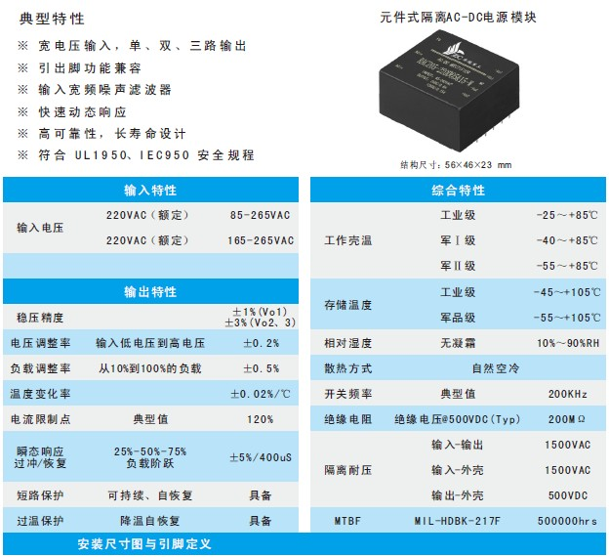
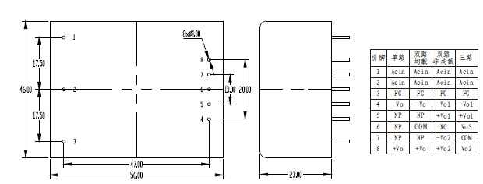
产品型号 | 标准输入 | 输入电压 | 输出电压 | 输出电流 | 纹波和噪声 | 效率
RACZ05-220S3.3 | 220 | 165-265 | 3.3 | 1.2 | 50 | 71
RACZ05-220S05 | 220 | 165-265 | 5 | 1 | 50 | 79
RACZ05-220S09 | 220 | 165-265 | 9 | 0.56 | 70 | 78
RACZ05-220S12 | 220 | 165-265 | 12 | 0.41 | 120 | 78
RACZ05-220S13.8 | 220 | 165-265 | 13.8 | 0.36 | 120 | 78
RACZ05-220S15 | 220 | 165-265 | 15 | 0.33 | 150 | 80
RACZ05-220S18 | 220 | 165-265 | 18 | 0.28 | 150 | 79
RACZ05-220S20 | 220 | 165-265 | 20 | 0.25 | 150 | 79
RACZ05-220S24 | 220 | 165-265 | 24 | 0.21 | 200 | 79
RACZ05-220S28 | 220 | 165-265 | 28 | 0.18 | 250 | 80
RACZ05-220S48 | 220 | 165-265 | 48 | 0.11 | 300 | 77
RACZ05-220D05 | 220 | 165-265 | ±05 | 0.5/0.5 | 50/50 | 78
RACZ05-220D12 | 220 | 165-265 | ±12 | 0.21/0.21 | 120/120 | 77
RACZ05-220D15 | 220 | 165-265 | ±15 | 0.17/0.17 | 150/150 | 80
RACZ05-220D24 | 220 | 165-265 | ±24 | 0.1/0.1 | 200/200 | 78
RACZ05-220D05&05 | 220 | 165-265 | 05&05 | 1/0.1 | 50/50 | 76
RACZ05-220D05&12 | 220 | 165-265 | 05&12 | 0.8/0.1 | 50/120 | 76
RACZ05-220D05&24 | 220 | 165-265 | 05&24 | 0.6/0.1 | 50/200 | 77
RACZ05-220D05&05 | 220 | 165-265 | 05&05 | 0.8/0.2 | 50/50 | 76
RACZ05-220D05&12 | 220 | 165-265 | 05&12 | 0.6/0.2 | 50/120 | 78
RACZ05-220D05&15 | 220 | 165-265 | 05&15 | 0.6/0.15 | 50/150 | 78
RACZ05-220D05&05 | 220 | 165-265 | 05&05 | 0.7/0.3 | 50/50 | 75
RACZ05-220T05&05 | 220 | 165-265 | ±5&5 | 0.8/0.1/0.1 | 50/50/50 | 76
RACZ05-220T12&05 | 220 | 165-265 | ±12&5 | 0.6/0.1/0.1 | 120/120/50 | 76
RACZ05-220T15&05 | 220 | 165-265 | ±15&5 | 0.6/0.08/0.08 | 150/150/50 | 76
RACZ05-220S3.3-W | 220 | 85-265 | 3.3 | 1.2 | 50 | 71
RACZ05-220S05-W | 220 | 85-265 | 5 | 1 | 50 | 79
RACZ05-220S09-W | 220 | 85-265 | 9 | 0.56 | 70 | 78
RACZ05-220S12-W | 220 | 85-265 | 12 | 0.41 | 120 | 78
RACZ05-220S13.8-W | 220 | 85-265 | 13.8 | 0.36 | 120 | 78
RACZ05-220S15-W | 220 | 85-265 | 15 | 0.33 | 150 | 80
RACZ05-220S18-W | 220 | 85-265 | 18 | 0.28 | 150 | 79
RACZ05-220S20-W | 220 | 85-265 | 20 | 0.25 | 150 | 79
RACZ05-220S24-W | 220 | 85-265 | 24 | 0.21 | 200 | 79
RACZ05-220S28-W | 220 | 85-265 | 28 | 0.18 | 250 | 80
RACZ05-220S48-W | 220 | 85-265 | 48 | 0.11 | 300 | 77
RACZ05-220D05-W | 220 | 85-265 | ±05 | 0.5/0.5 | 50/50 | 78
RACZ05-220D12-W | 220 | 85-265 | ±12 | 0.21/0.21 | 120/120 | 77
RACZ05-220D15-W | 220 | 85-265 | ±15 | 0.17/0.17 | 150/150 | 80
RACZ05-220D24-W | 220 | 85-265 | ±24 | 0.1/0.1 | 200/200 | 78
RACZ05-220D05&05-W | 220 | 85-265 | 05&05 | 1/0.1 | 50/50 | 76
RACZ05-220D05&12-W | 220 | 85-265 | 05&12 | 0.8/0.1 | 50/120 | 76
RACZ05-220D05&24-W | 220 | 85-265 | 05&24 | 0.6/0.1 | 50/200 | 77
RACZ05-220D05&05-W | 220 | 85-265 | 05&05 | 0.8/0.2 | 50/50 | 76
RACZ05-220D05&12-W | 220 | 85-265 | 05&12 | 0.6/0.2 | 50/120 | 78
RACZ05-220D05&15-W | 220 | 85-265 | 05&15 | 0.6/0.15 | 50/150 | 78
RACZ05-220D05&05-W | 220 | 85-265 | 05&05 | 0.7/0.3 | 50/50 | 75
RACZ05-220T05&05-W | 220 | 85-265 | ±5&5 | 0.8/0.1/0.1 | 50/50/50 | 76
RACZ05-220T12&05-W | 220 | 85-265 | ±12&5 | 0.6/0.1/0.1 | 120/120/50 | 76
RACZ05-220T15&05-W | 220 | 85-265 | ±15&5 | 0.6/0.08/0.08 | 150/150/50 | 76

