RAEZ系列
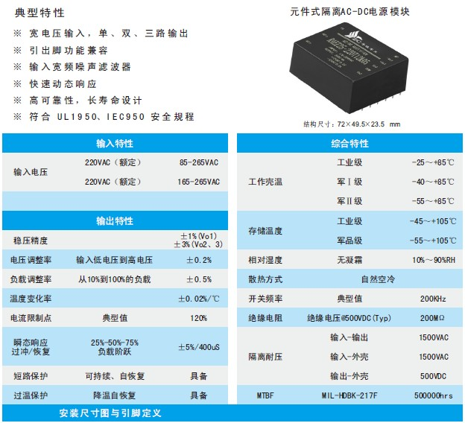
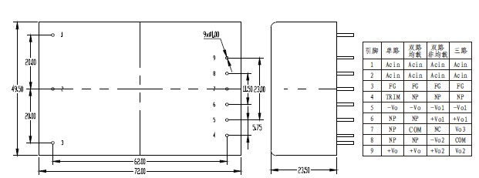
产品型号 | 标准输入 | 输入电压 | 输出电压 | 输出电流 | 纹波和噪声 | 效率
RAEZ25-220S05 | 220 | 165-265 | 5 | 5 | 50 | 80
RAEZ25-220S12 | 220 | 165-265 | 12 | 2.08 | 120 | 81
RAEZ25-220S13.8 | 220 | 165-265 | 13.8 | 1.81 | 120 | 82
RAEZ25-220S15 | 220 | 165-265 | 15 | 1.67 | 150 | 82
RAEZ25-220S24 | 220 | 165-265 | 24 | 1.04 | 200 | 83
RAEZ25-220S48 | 220 | 165-265 | 48 | 0.52 | 300 | 80
RAEZ25-220D05 | 220 | 165-265 | ±05 | 2.5/2.5 | 50/50 | 81
RAEZ25-220D12 | 220 | 165-265 | ±12 | 1.04/1.04 | 120/120 | 83
RAEZ25-220D15 | 220 | 165-265 | ±15 | 0.83/0.83 | 150/150 | 83
RAEZ25-220D24 | 220 | 165-265 | ±24 | 0.52/0.52 | 200/200 | 83
RAEZ25-220D05&05 | 220 | 165-265 | 05&05 | 5/0.1 | 50/50 | 79
RAEZ25-220D05&12 | 220 | 165-265 | 05&12 | 4.8/0.1 | 120/120 | 79
RAEZ25-220D05&15 | 220 | 165-265 | 05&15 | 4.7/0.1 | 150/150 | 80
RAEZ25-220D05&24 | 220 | 165-265 | 05&24 | 4.5/0.1 | 200/200 | 81
RAEZ25-220D05&05 | 220 | 165-265 | 05&05 | 4.8/0.2 | 50/50 | 79
RAEZ25-220D05&12 | 220 | 165-265 | 05&12 | 4.5/0.2 | 120/120 | 80
RAEZ25-220D05&15 | 220 | 165-265 | 05&15 | 4.4/0.2 | 150/150 | 81
RAEZ25-220D05&24 | 220 | 165-265 | 05&24 | 4/0.2 | 200/200 | 82
RAEZ25-220T12&05 | 220 | 165-265 | ±12&05 | 0.2/0.2/4 | 120/120/50 | 79
RAEZ25-220T15&05 | 220 | 165-265 | ±15&05 | 0.2/0.2/3.8 | 150/150/50 | 80
RAEZ25-220T24&05 | 220 | 165-265 | ±24&05 | 0.2/0.2/3.1 | 200/200/50 | 80
RAEZ25-220T05&05 | 220 | 165-265 | ±05&05 | 0.8/0.8/3.4 | 50/50/50 | 81
RAEZ25-220T12&05 | 220 | 165-265 | ±12&05 | 0.4/0.4/3.1 | 120/120/50 | 81
RAEZ25-220T15&05 | 220 | 165-265 | ±15&05 | 0.4/0.4/2.6 | 150/150/50 | 81
RAEZ25-220T24&05 | 220 | 165-265 | ±24&05 | 0.25/0.25/2.6 | 200/200/50 | 82
RAEZ25-220S05-W | 220 | 85-265 | 5 | 5 | 50 | 81
RAEZ25-220S12-W | 220 | 85-265 | 12 | 2.08 | 120 | 82
RAEZ25-220S13.8-W | 220 | 85-265 | 13.8 | 1.81 | 120 | 82
RAEZ25-220S15-W | 220 | 85-265 | 15 | 1.67 | 150 | 83
RAEZ25-220S24-W | 220 | 85-265 | 24 | 1.04 | 200 | 83
RAEZ25-220S48-W | 220 | 85-265 | 48 | 0.52 | 300 | 82
RAEZ25-220D05-W | 220 | 85-265 | ±05 | 2.5/2.5 | 50/50 | 81
RAEZ25-220D12-W | 220 | 85-265 | ±12 | 1.04/1.04 | 120/120 | 83
RAEZ25-220D15-W | 220 | 85-265 | ±15 | 0.83/0.83 | 150/150 | 83
RAEZ25-220D24-W | 220 | 85-265 | ±24 | 0.52/0.52 | 200/200 | 83
RAEZ25-220D05&05-W | 220 | 85-265 | 05&05 | 5/0.1 | 50/50 | 79
RAEZ25-220D05&12-W | 220 | 85-265 | 05&12 | 4.8/0.1 | 120/120 | 79
RAEZ25-220D05&15-W | 220 | 85-265 | 05&15 | 4.7/0.1 | 150/150 | 80
RAEZ25-220D05&24-W | 220 | 85-265 | 05&24 | 4.5/0.1 | 200/200 | 81
RAEZ25-220D05&05-W | 220 | 85-265 | 05&05 | 4.8/0.2 | 50/50 | 79
RAEZ25-220D05&12-W | 220 | 85-265 | 05&12 | 4.5/0.2 | 120/120 | 80
RAEZ25-220D05&15-W | 220 | 85-265 | 05&15 | 4.4/0.2 | 150/150 | 81
RAEZ25-220D05&24-W | 220 | 85-265 | 05&24 | 4/0.2 | 200/200 | 82
RAEZ25-220T12&05-W | 220 | 85-265 | ±12&05 | 0.2/0.2/4 | 120/120/50 | 79
RAEZ25-220T15&05-W | 220 | 85-265 | ±15&05 | 0.2/0.2/3.8 | 150/150/50 | 80
RAEZ25-220T24&05-W | 220 | 85-265 | ±24&05 | 0.2/0.2/3.1 | 200/200/50 | 80
RAEZ25-220T05&05-W | 220 | 85-265 | ±05&05 | 0.8/0.8/3.4 | 50/50/50 | 81
RAEZ25-220T12&05-W | 220 | 85-265 | ±12&05 | 0.4/0.4/3.1 | 120/120/50 | 81
RAEZ25-220T15&05-W | 220 | 85-265 | ±15&05 | 0.4/0.4/2.6 | 150/150/50 | 81
RAEZ25-220T24&05-W | 220 | 85-265 | ±24&05 | 0.25/0.25/2.6 | 200/200/50 | 82

