RDAZ系列
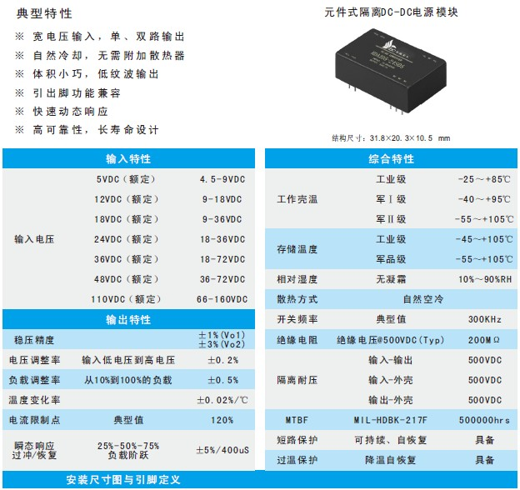
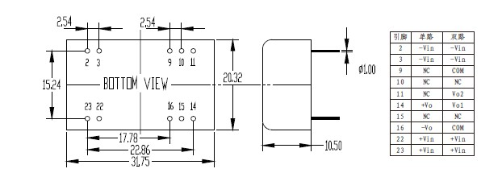
产品型号 | 标准输入 | 输入电压 | 输出电压 | 输出电流 | 纹波和噪声 | 效率
RDAZ03-05S05 | 5 | 4.5-9 | 5 | 0.6 | 50 | 72
RDAZ03-05S12 | 5 | 4.5-9 | 12 | 0.25 | 100 | 72
RDAZ03-05S15 | 5 | 4.5-9 | 15 | 0.2 | 120 | 72
RDAZ03-05D05 | 5 | 4.5-9 | ±5 | 0.3/0.3 | 50/50 | 72
RDAZ03-05D05 | 5 | 4.5-9 | ±12 | 0.13/0.13 | 100/100 | 72
RDAZ05-12S3.3 | 12 | 9-18 | 3.3 | 1.52 | 50 | 73
RDAZ05-12S05 | 12 | 9-18 | 5 | 1 | 50 | 74
RDAZ05-12S12 | 12 | 9-18 | 12 | 0.42 | 100 | 75
RDAZ05-12S15 | 12 | 9-18 | 15 | 0.33 | 120 | 75
RDAZ05-12S24 | 12 | 9-18 | 24 | 0.21 | 200 | 73
RDAZ05-12S48 | 12 | 9-18 | 48 | 0.1 | 250 | 74
RDAZ05-12D05 | 12 | 9-18 | ±5 | 0.5/0.5 | 50/50 | 76
RDAZ05-12D12 | 12 | 9-18 | ±12 | 0.21/0.21 | 100/100 | 78
RDAZ05-12D15 | 12 | 9-18 | ±15 | 0.17/0.17 | 120/120 | 79
RDAZ05-24S3.3 | 24 | 18-36 | 3.3 | 1.52 | 50 | 74
RDAZ05-24S05 | 24 | 18-36 | 5 | 1 | 50 | 76
RDAZ05-24S12 | 24 | 18-36 | 12 | 0.42 | 100 | 76
RDAZ05-24S15 | 24 | 18-36 | 15 | 0.33 | 120 | 76
RDAZ05-24S24 | 24 | 18-36 | 24 | 0.21 | 200 | 75
RDAZ05-24S48 | 24 | 18-36 | 48 | 0.1 | 250 | 75
RDAZ05-24D05 | 24 | 18-36 | ±5 | 0.5/0.5 | 50/50 | 78
RDAZ05-24D12 | 24 | 18-36 | ±12 | 0.21/0.21 | 100/100 | 79
RDAZ05-24D15 | 24 | 18-36 | ±15 | 0.17/0.17 | 120/120 | 79
RDAZ05-48S3.3 | 48 | 36-72 | 3.3 | 1.52 | 50 | 74
RDAZ05-48S05 | 48 | 36-72 | 5 | 1 | 50 | 76
RDAZ05-48S12 | 48 | 36-72 | 12 | 0.42 | 100 | 78
RDAZ05-48S15 | 48 | 36-72 | 15 | 0.33 | 120 | 78
RDAZ05-48S24 | 48 | 36-72 | 24 | 0.21 | 200 | 76
RDAZ05-48S48 | 48 | 36-72 | 48 | 0.1 | 250 | 76
RDAZ05-48D05 | 48 | 36-72 | ±5 | 0.5/0.5 | 50/50 | 79
RDAZ05-48D12 | 48 | 36-72 | ±12 | 0.21/0.21 | 100/100 | 79
RDAZ05-48D15 | 48 | 36-72 | ±15 | 0.17/0.17 | 120/120 | 80
RDAZ05-110S05 | 110 | 66-160 | 5 | 1 | 50 | 75
RDAZ05-110S12 | 110 | 66-160 | 12 | 0.42 | 100 | 78
RDAZ05-110S15 | 110 | 66-160 | 15 | 0.33 | 120 | 79
RDAZ05-110D05 | 110 | 66-160 | ±5 | 0.5/0.5 | 50/50 | 76
RDAZ05-110D12 | 110 | 66-160 | ±12 | 0.21/0.21 | 100/100 | 78
RDAZ05-110D15 | 110 | 66-160 | ±15 | 0.17/0.17 | 120/120 | 80
RDAZ05-18S05 | 18 | 9-36 | 5 | 1 | 50 | 75
RDAZ05-18S12 | 18 | 9-36 | 12 | 0.42 | 100 | 75
RDAZ05-18S15 | 18 | 9-36 | 15 | 0.33 | 120 | 75
RDAZ05-18D05 | 18 | 9-36 | ±5 | 0.5/0.5 | 50/50 | 77
RDAZ05-18D12 | 18 | 9-36 | ±12 | 0.21/0.21 | 100/100 | 78
RDAZ05-18D15 | 18 | 9-36 | ±15 | 0.17/0.17 | 120/120 | 78
RDAZ05-36S05 | 36 | 18-72 | 5 | 1 | 50 | 75
RDAZ05-36S12 | 36 | 18-72 | 12 | 0.42 | 100 | 77
RDAZ05-36S15 | 36 | 18-72 | 15 | 0.33 | 120 | 77
RDAZ05-36D05 | 36 | 18-72 | ±5 | 0.5/0.5 | 50/50 | 78
RDAZ05-36D12 | 36 | 18-72 | ±12 | 0.21/0.21 | 100/100 | 78
RDAZ05-36D15 | 36 | 18-72 | ±15 | 0.17/0.17 | 120/120 | 79

