RDCZ系列
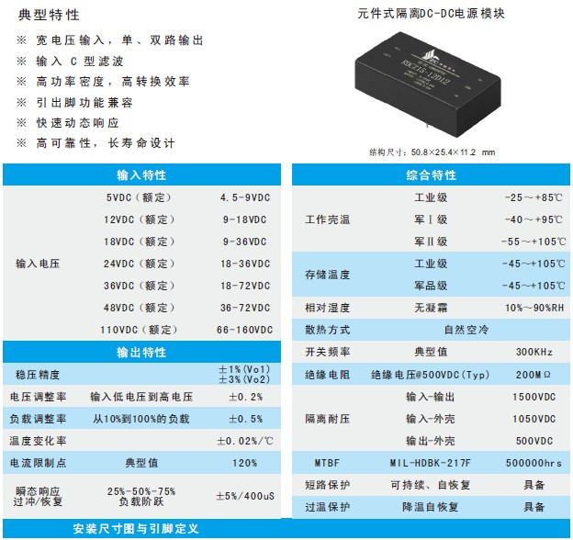
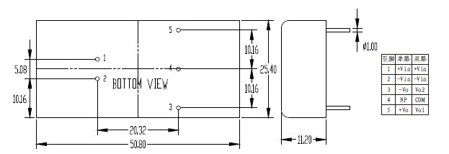
产品型号 | 标准输入 | 输入电压 | 输出电压 | 输出电流 | 纹波和噪声 | 效率
RDCZ10-05S05 | 5 | 4.5-9 | 5 | 2 | 50 | 78
RDCZ10-05S12 | 5 | 4.5-9 | 12 | 0.83 | 100 | 79
RDCZ10-05D05 | 5 | 4.5-9 | ±5 | 1/1 | 50/50 | 79
RDCZ10-05D12 | 5 | 4.5-9 | ±12 | 0.42/0.42 | 100/100 | 79
RDCZ15-12S05 | 12 | 9-18 | 5 | 3 | 50 | 80
RDCZ15-12S12 | 12 | 9-18 | 12 | 1.25 | 100 | 82
RDCZ15-12S24 | 12 | 9-18 | 24 | 0.63 | 200 | 82
RDCZ15-12D05 | 12 | 9-18 | ±5 | 1.5/1.5 | 50/50 | 79
RDCZ15-12D12 | 12 | 9-18 | ±12 | 0.63/0.63 | 100/100 | 82
RDCZ15-12D15 | 12 | 9-18 | ±15 | 0.5/0.5 | 120/120 | 82
RDCZ15-24S05 | 24 | 18-36 | 5 | 3 | 50 | 82
RDCZ15-24S12 | 24 | 18-36 | 12 | 1.25 | 100 | 85
RDCZ15-24S24 | 24 | 18-36 | 24 | 0.63 | 200 | 85
RDCZ15-24D05 | 24 | 18-36 | ±5 | 1.5/1.5 | 50/50 | 83
RDCZ15-24D12 | 24 | 18-36 | ±12 | 0.63/0.63 | 100/100 | 85
RDCZ15-24D15 | 24 | 18-36 | ±15 | 0.5/0.5 | 120/120 | 86
RDCZG20-24S05 | 24 | 18-36 | 5 | 4 | 50 | 85
RDCZG20-24S12 | 24 | 18-36 | 12 | 1.67 | 100 | 86
RDCZG20-24S24 | 24 | 18-36 | 15 | 1.33 | 120 | 86
RDCZ15-48S05 | 48 | 36-72 | 5 | 3 | 50 | 83
RDCZ15-48S12 | 48 | 36-72 | 12 | 1.25 | 100 | 85
RDCZ15-48S24 | 48 | 36-72 | 24 | 0.63 | 200 | 86
RDCZ15-48D05 | 48 | 36-72 | ±5 | 1.5/1.5 | 50/50 | 84
RDCZ15-48D12 | 48 | 36-72 | ±12 | 0.63/0.63 | 100/100 | 85
RDCZ15-48D15 | 48 | 36-72 | ±15 | 0.5/0.5 | 120/120 | 86
RDCZG20-48S05 | 48 | 36-72 | 5 | 4 | 50 | 84
RDCZG20-48S12 | 48 | 36-72 | 12 | 1.67 | 100 | 86
RDCZG20-48S24 | 48 | 36-72 | 15 | 1.33 | 120 | 86
RDCZG25-48S12 | 48 | 36-72 | 12 | 2.08 | 100 | 87
RDCZG25-48S24 | 48 | 36-72 | 15 | 1.67 | 120 | 87
RDCZ15-18S05 | 18 | 9-36 | 5 | 3 | 50 | 81
RDCZ15-18S12 | 18 | 9-36 | 12 | 1.25 | 100 | 83
RDCZ15-18D05 | 18 | 9-36 | ±5 | 1.5/1.5 | 50/50 | 83
RDCZ15-18D12 | 18 | 9-36 | ±12 | 0.63/0.63 | 100/100 | 83
RDCZ15-18D15 | 18 | 9-36 | ±15 | 0.5/0.5 | 120/120 | 85
RDCZ15-36S05 | 36 | 18-72 | 5 | 3 | 50 | 83
RDCZ15-36S12 | 36 | 18-72 | 12 | 1.25 | 100 | 85
RDCZ15-36D05 | 36 | 18-72 | ±5 | 1.5/1.5 | 50/50 | 81
RDCZ15-36D12 | 36 | 18-72 | ±12 | 0.63/0.63 | 100/100 | 82
RDCZ15-36D15 | 36 | 18-72 | ±15 | 0.5/0.5 | 120/120 | 83
RDCZ15-110S05 | 110 | 66-160 | 5 | 3 | 50 | 83
RDCZ15-110S12 | 110 | 66-160 | 12 | 1.25 | 100 | 85
RDCZ15-110D05 | 110 | 66-160 | ±5 | 1.5/1.5 | 50/50 | 83
RDCZ15-110D12 | 110 | 66-160 | ±12 | 0.63/0.63 | 100/100 | 85
RDCZ15-110D15 | 110 | 66-160 | ±15 | 0.5/0.5 | 120/120 | 86
RDCZG20-110S05 | 110 | 66-160 | 5 | 4 | 50 | 84
RDCZG20-110S12 | 110 | 66-160 | 12 | 1.67 | 100 | 86
RDCZG20-110S24 | 110 | 66-160 | 15 | 1.33 | 120 | 86
RDCZG25-110S12 | 110 | 66-160 | 12 | 2.08 | 100 | 87
RDCZG25-110S24 | 110 | 66-160 | 15 | 1.67 | 120 | 87

