RDDZ系列
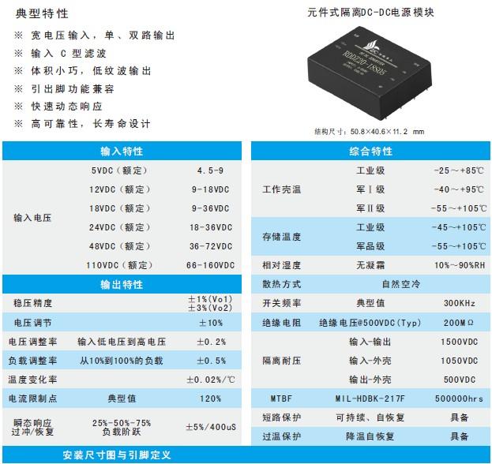
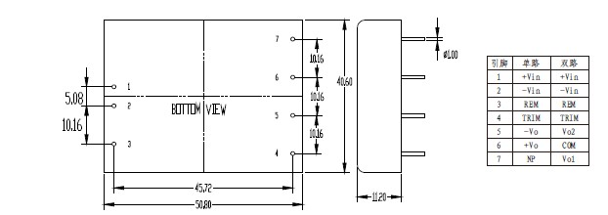
产品型号 | 标准输入 | 输入电压 | 输出电压 | 输出电流 | 纹波和噪声 | 效率
RDDZ20-12S3.3 | 12 | 9-18 | 3.3 | 5 | 50 | 81
RDDZ20-12S05 | 12 | 9-18 | 5 | 4 | 50 | 83
RDDZ20-12S12 | 12 | 9-18 | 12 | 1.67 | 100 | 84
RDDZ20-12S15 | 12 | 9-18 | 15 | 1.33 | 120 | 84
RDDZ20-12S24 | 12 | 9-18 | 24 | 0.83 | 200 | 85
RDDZ20-12D05 | 12 | 9-18 | ±5 | 2/2 | 50/50 | 80
RDDZ20-12D12 | 12 | 9-18 | ±12 | 0.83/0.83 | 100/100 | 83
RDDZ20-12D15 | 12 | 9-18 | ±15 | 0.67/0.67 | 120/120 | 84
RDDZ30-12S05 | 12 | 9-18 | 5 | 6 | 50 | 82
RDDZ30-12S12 | 12 | 9-18 | 12 | 2.5 | 100 | 83
RDDZ30-12D05 | 12 | 9-18 | ±5 | 3/3 | 50/50 | 80
RDDZ30-12D12 | 12 | 9-18 | ±12 | 1.25/1.25 | 100/100 | 83
RDDZ20-24S3.3 | 24 | 18-36 | 3.3 | 5 | 50 | 81
RDDZ20-24S05 | 24 | 18-36 | 5 | 4 | 50 | 83
RDDZ20-24S12 | 24 | 18-36 | 12 | 1.67 | 100 | 84
RDDZ20-24S15 | 24 | 18-36 | 15 | 1.33 | 120 | 84
RDDZ20-24S24 | 24 | 18-36 | 24 | 0.83 | 200 | 85
RDDZ20-24D05 | 24 | 18-36 | ±5 | 2/2 | 50/50 | 83
RDDZ20-24D12 | 24 | 18-36 | ±12 | 0.83/0.83 | 100/100 | 83
RDDZ20-24D15 | 24 | 18-36 | ±15 | 0.67/0.67 | 120/120 | 84
RDDZ30-24S12 | 24 | 18-36 | 12 | 2.5 | 100 | 85
RDDZ30-24S24 | 24 | 18-36 | 24 | 1.25 | 200 | 86
RDDZ30-24D05 | 24 | 18-36 | ±5 | 3/3 | 50/50 | 83
RDDZ30-24D12 | 24 | 18-36 | ±12 | 1.25/1.25 | 100/100 | 85
RDDZ30-24D24 | 24 | 18-36 | ±24 | 0.63/0.63 | 200/200 | 86
RDDZ20-48S3.3 | 48 | 36-72 | 3.3 | 5 | 50 | 82
RDDZ20-48S05 | 48 | 36-72 | 5 | 4 | 50 | 83
RDDZ20-48S12 | 48 | 36-72 | 12 | 1.67 | 100 | 85
RDDZ20-48S15 | 48 | 36-72 | 15 | 1.33 | 120 | 85
RDDZ20-48S24 | 48 | 36-72 | 24 | 0.83 | 200 | 86
RDDZ20-48S48 | 48 | 36-72 | 48 | 0.42 | 250 | 84
RDDZ20-48D05 | 48 | 36-72 | ±5 | 2/2 | 50/50 | 84
RDDZ20-48D12 | 48 | 36-72 | ±12 | 0.83/0.83 | 100/100 | 85
RDDZ20-48D24 | 48 | 36-72 | ±24 | 0.42/0.42 | 200/200 | 86
RDDZ30-48S12 | 48 | 36-72 | 12 | 2.5 | 100 | 86
RDDZ30-48S24 | 48 | 36-72 | 24 | 1.25 | 200 | 87
RDDZ30-48S48 | 48 | 36-72 | 48 | 0.63 | 250 | 87
RDDZ30-48D05 | 48 | 36-72 | ±5 | 3/3 | 50/50 | 84
RDDZ30-48D12 | 48 | 36-72 | ±12 | 1.25/1.25 | 100/100 | 86
RDDZ30-48D24 | 48 | 36-72 | ±24 | 0.63/0.63 | 200/200 | 86
RDDZ20-110S12 | 110 | 36-72 | 12 | 1.67 | 120 | 85
RDDZ20-110S24 | 110 | 66-160 | 24 | 0.83 | 200 | 84
RDDZ20-110S48 | 110 | 66-160 | 48 | 0.42 | 250 | 83
RDDZ20-110D24 | 110 | 66-160 | ±24 | 0.42/0.42 | 200/200 | 83
RDDZ20-110D48 | 110 | 66-160 | ±48 | 0.21/0.21 | 250/250 | 83
RDDZ20-18S05 | 18 | 9-36 | 5 | 4 | 50 | 82
RDDZ20-18S12 | 18 | 9-36 | 12 | 1.67 | 100 | 86
RDDZ20-18S24 | 18 | 9-36 | 24 | 0.83 | 200 | 86
RDDZ20-18D05 | 18 | 9-36 | ±5 | 2/2 | 50/50 | 82
RDDZ20-18D12 | 18 | 9-36 | ±12 | 0.83/0.83 | 100/100 | 85

